

COLLEGE OF INFORMATICS AND ELECTRONICS

DEPARTMENT OF MATHEMATICS & STATISTICS

END OF SEMESTER ASSESSMENT PAPER

MODULE CODE: MA4005 SEMESTER: Autumn 2007-08

MODULE TITLE: Engineering Maths T1 DURATION OF EXAM: 2.5 hours

LECTURER: J Leahy GRADING SCHEME:
Examination: 100%

EXTERNAL EXAMINER: Prof J King

INSTRUCTIONS TO CANDIDATES
Answer One (1) question from each Section A and B and any three (3) other questions. Five questions in total. All questions carry equal marks.

-2-

MA4005 Engineering Maths T1

SECTION A
Marks

1. (a) If 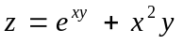 prove

(i) 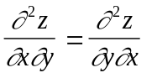 5

(ii) 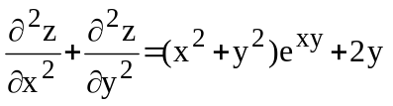. 5

(b) The volume, V, of a box is calculated from the formula 10
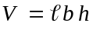 using the measurements 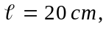
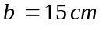 and 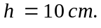 The maximum error in each measurement
is 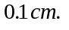 Find, using partial derivatives the maximum error in the
calculated value of V.

2. (a) Evaluate the integrals

(i) 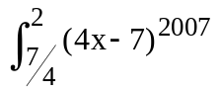dx 3

(ii) 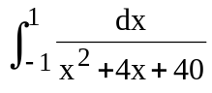. 3

(b) Find the area of the region bounded by the curves 6

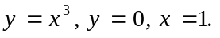

(c) Find the centroid of the area in (b). 8

-3-

MA4005 Engineering Maths T1

Marks

3. (a) Find the general solution of each of the differential equations

(i) 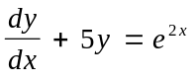 6

(ii) 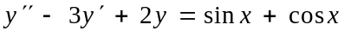. 6

(b) A body moves so that its velocity at any time t is directly
proportional to its distance x from a fixed point. Its equation
of motion is

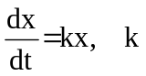constant.

Find an expression for x in terms of t
given that 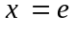 at 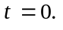 8

4. (a) Calculate from the definition the Laplace transform of the function 4
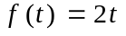.

(b) Use the tables to find the Laplace transform of the functions 2

(i) 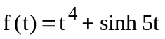

(ii) 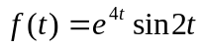. 2

(c) Find the inverse Laplace transform of the function

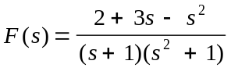. 6

(d) Use the Laplace transform to find the solution of the 6
boundary value problem

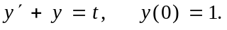

-4-

MA4005 Engineering Maths T1

Marks

5. (a) Find the period of the following periodic functions

(i) 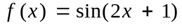 2

(ii) 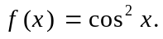 2

Determine if either of these functions is even or odd. 2

(b) The function 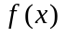 is periodic of period 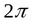and is
defined over the interval 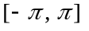 by

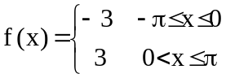, 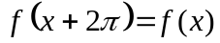.

Find its Fourier series. 14

SECTION B

6. (a) Find one non-trivial solution of the homogeneous system of 6
linear equations

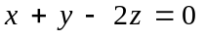
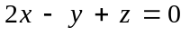
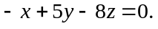

-5-
MA4005 Engineering Maths T1

(b) Find the inverse of the matrix 7

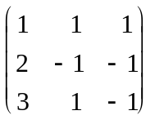

and hence solve the system 7

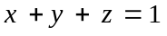
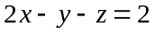
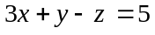.

Q.7 (a) State the axioms for a vector space. 4

(b) Show the set R of all real numbers with the usual
operations of addition and multiplication by a scalar
is a vector space. 6

(c ) Determine which of the following sets of vectors are
linearly independent in 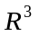

(i)

(ii) . 5

(d) Show that the vectors
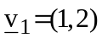 and 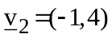
span 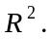

Q.8 Find the eigenvalues and corresponding eigenvectors of
the matrix

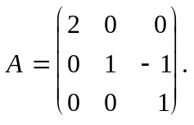 14

Determine the Rank and nullity of A. 6

